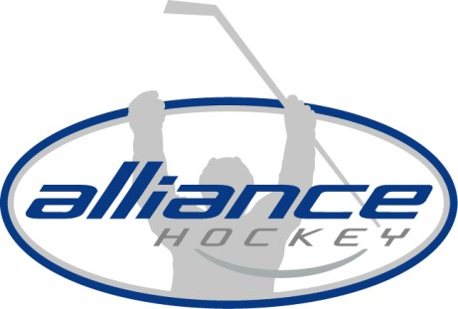
ALLIANCE HOCKEY
55 Lorne Ave, Unit #4
Stratford, Ontario N5A 6S4
Tel (519) 273-7209
Fax (519) 273-2114
www.alliancehockey.com

ALLIANCE HOCKEY BULLETIN
ID: 23-026

Date: November 6, 2023

To: All ALLIANCE Hockey Members

Re: Zero Tolerance - Inappropriate Conduct

PLEASE ENSURE THIS BULLETIN RECEIVES THE WIDEST DISTRIBUTION

To date, the number of maltreatment and cases of discrimination are overwhelming. Minor hockey is better than this! We are calling on all teams, including coaches, players, and administrators to be proactive in the pursuit of eliminating all maltreatment and discrimination.

THINK - SKATE AWAY - NO CHIRPING - PLAY THE GAME

Most cases are reported by on-ice Officials and often players are being penalized for remarks said in retaliation. It is worth the reminder that the minimum call as it relates to Rule 11.4 is a 5-game suspension.

The procedure in managing allegations of discrimination is for the ALLIANCE Hockey Maltreatment Committee to follow up with the Minor Hockey Association whose participant has been alleged to have used a discriminatory slur and when proven, a penalty results. When an allegation is not proven, team education and a warning is the noted procedure. Allegations and accusations are managed by the ALLIANCE Hockey Maltreatment Committee and in circumstances where there is an additional allegation or call by an Official, the result is a minimum 5 game suspension with the potential of increasing the minimum.

Rule 11.4 – Discrimination
- The primary focus is related to discriminatory language and actions in hockey.
- Eliminating discrimination from the game is part of officials’ responsibility to prevent maltreatment.
- This rule pertains to both: o Incidents that are witnessed by an official.
  - Incidents that are reported to an official by a participant.
- The rule states:
Any player, goaltender or team official who engages in verbal taunts, insults or intimidation based on discriminatory grounds shall be assessed a Gross Misconduct penalty. Discriminatory grounds include the following, without limitation: o Race, national or ethnic origin, skin colour or language spoken o Religion, faith or beliefs
  - Age
  - Sex, sexual orientation or gender identity / expression  Marital or familial status o Genetic characteristics o Disability

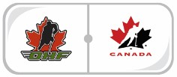
TOGETHER WE ACHIEVE MORE
1 | P a g e

- The basic text is the same as before, but the list of grounds has been expanded… the spirit of the rule is that discriminatory language of any type has no place in hockey.
- The rule also specifies how reporting is to occur: o The Referee shall report the individual(s) by completing a Game Incident Report, including full details and submitting the Report to the appropriate Member or League delegate.
  - If an incident occurs that was not witnessed by the Officials and is reported to the Referee, the Referee shall report the individual(s) to an appropriate member of each team’s bench staff.
  - The Referee shall complete a Game Incident Report, including full details and shall submit the Report to the appropriate Member.

Let’s work together to make the game a fun and safe environment for all involved.

TOGETHER WE ACHIEVE MORE
2 | P a g e

